CHANGES HISTORY
PIC | Date | Remarks
BJM.MR | 2018.05.02 | Created
Ghaida | 2018.04.27

TOC
- Parameter Securities Country
- Parameter Securities External System
- Parameter Securities Sector Class
- Parameter Securities Sector Class Member Company
- Parameter Securities Sector Class Member Sub Sector
- Parameter Securities Region
- Parameter Securities Market
- Parameter Securities XRate
- Parameter Securities Sub Sector
- Parameter Securities Company Position
- Parameter Securities Sector Class Member Sector
- Parameter Securities Benchmark Class
- Parameter Securities Benchmark Class Composition
- Parameter Securities Benchmark
- Parameter Securities Sector
- Parameter Securities Index
- Parameter Afa Charges
- Parameter Securities Pricing
- Parameter OMS
- Parameter Securities Benchmark Id External
- Parameter Securities Index Type

Diagram ENTITY RELATIONSHIP
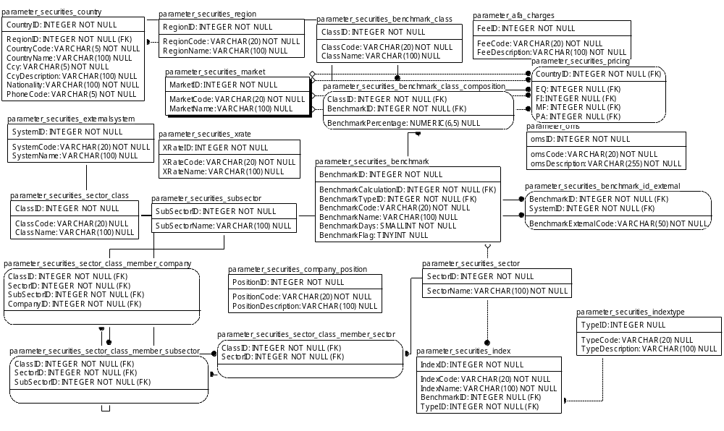

TABLE RELATIONSHIP
No | Table 1 | Table 2 | Type (1:1; 1:N; M:N) | Description
 | parameter_securities_region | parameter_securities_country | M:N
 | parameter_securities_country | parameter_securities_pricing | 1:1
 | parameter_securities_externalsystem | parameter_securities_benchmark_id_external | M:N
 | parameter_securities_sector_class_member_subsector | parameter_securities_sector_class_member_company | M:N
 | parameter_securities _subsector | parameter_securities_sector_class_member_subsector | M:N
 | parameter_securities_sector_class | parameter_securities_sector_class_member_sector | M:N
 | parameter_securities_sector_class_member_sector | parameter_securities_sector_class_member_subsector | M:N
 | parameter_securities_market | parameter_securities_pricing | M:N
 | parameter_securities_market | parameter_securities_pricing | M:N
 | parameter_securities_benchmark_class | parameter_securities_benchmark_class_composition | M:N
 | parameter_securities_market | parameter_securities_pricing | M:N
 | parameter_securities_market | parameter_securities_pricing | M:N
 | parameter_securities_benchmark | parameter_securities_benchmark_class_composition | M:N
 | parameter_securities_sector | parameter_securities_sector_class_member_sector | M:N
 | parameter_securities_benchmark | parameter_securities_index | M:N
 | parameter_securities_benchmark | parameter_securities_benchmark_id_external | M:N
 | parameter_securities_indextype | parameter_securities_index | M:N

Name |  | parameter_securities_country
Objective
No | Column |  | Type | Rule  (PK, FK, Key, NN, Unik, Index) | Description
1. | CountryID |  | Integer | NN
2. | RegionID |  | Integer | FK
3. | CountryCode |  | Varchar(5) | NN
4. | CountryName |  | Varchar(100) | Null
5. | Ccy |  | Varchar(5) | NN
6. | CcyDescription |  | Varchar(100) | Null
7. | Nationality |  | Varchar(100) | NN
8. | PhoneCode |  | Varchar(5) | NN

SAMPLE DATA
No | Column | Sample 1 | Sample 2 | Sample 3 | Sample 4
1. | CountryID | 1 | 2 | 3 | 4
2. | RegionID | 1 | 3 | 1 | 4
3. | CountryCode | ID | US | SG | JP
4. | CountryName | Indonesia | United States of America | Singapore | Japan
5. | Ccy | IDR | USD | SGD | JPY
6. | CcyDescription | Indonesian rupiah | US Dollar | Singapore Dollar | Japanese yen
7. | Nationality | Indonesia | American | Singapore | Japan
8. | PhoneCode | 62 | 1 | 65 | 81

Name |  | parameter_securities_externalsystem
Objective
No | Column |  | Type | Rule  (PK, FK, Key, NN, Unik, Index) | Description
1. | SystemID |  | Integer | NN
2. | SystemCode |  | Varchar(20) | NN
3. | SystemName |  | Varchar(100) | Null

SAMPLE DATA
No | Column | Sample 1 | Sample 2 | Sample 3 | Sample 4
1. | SystemID | 1 | 2 | 3 | 4
2. | SystemCode | YAHOO | ISIN | CUSTODIAN | ID.SCBJK
3. | SystemName | Yahoo Ticker | ISIN Ticker | Custodian | Standard Chartered Bank-J

Name |  | parameter_securities_sector_class
Objective
No | Column |  | Type | Rule  (PK, FK, Key, NN, Unik, Index) | Description
1. | ClassID |  | Integer | NN
2. | ClassCode |  | Varchar(20) | Null
3. | ClassName |  | Varchar(100) | Null

SAMPLE DATA
No | Column | Sample 1 | Sample 2 | Sample 3 | Sample 4
1. | ClassID | 1 | 2 | 3
2. | ClassCode | Bloomberg | JCI | Bidang Usaha
3. | ClassName | Bloomberg Clasification | Jakarta Composite Index Class | Bidang Usaha

Name |  | parameter_securities_sector_class_member_company
Objective
No | Column |  | Type | Rule  (PK, FK, Key, NN, Unik, Index) | Description
1. | ClassID |  | Integer | FK
2. | SectorID |  | Integer | FK
3. | SubSectorID |  | Integer | FK
4. | CompanyID |  | Integer | FK

SAMPLE DATA
No | Column | Sample 1 | Sample 2 | Sample 3 | Sample 4
1. | ClassID | 1 | 1 | 1 | 1
2. | SectorID | 1 | 1 | 1 | 1
3. | SubSectorID | 1 | 1 | 1 | 1
4. | CompanyID | 11 | 29 | 37 | 40

Name |  | parameter_securities_sector_class_member_subsector
Objective
No | Column |  | Type | Rule  (PK, FK, Key, NN, Unik, Index) | Description
1. | ClassID |  | Integer | FK
2. | SectorID |  | Integer | FK
3. | SubSectorID |  | Integer | FK

SAMPLE DATA
No | Column | Sample 1 | Sample 2 | Sample 3 | Sample 4
1. | ClassID | 1 | 1 | 1 | 1
2. | SectorID | 1 | 2 | 4 | 5
3. | SubSectorID

Name |  | parameter_securities_region
Objective
No | Column |  | Type | Rule  (PK, FK, Key, NN, Unik, Index) | Description
1. | RegionID |  | Integer | NN
2. | RegionCode |  | Varchar(20) | NN
3. | RegionName |  | Varchar(100) | Null

SAMPLE DATA
No | Column | Sample 1 | Sample 2 | Sample 3 | Sample 4
1. | RegionID | 1 | 2 | 3 | 4
2. | RegionCode | SEA | NAM | EUR | EA
3. | RegionName | South East ASia | North America | Europe | East Asia

Name |  | parameter_securities_market
Objective
No | Column |  | Type | Rule  (PK, FK, Key, NN, Unik, Index) | Description
1. | MarketID |  | Integer | NN
2. | MarketCode |  | Varchar(20) | NN
3. | MarketName |  | Varchar(100) | Null

SAMPLE DATA
No | Column | Sample 1 | Sample 2 | Sample 3 | Sample 4
1. | MarketID | 1 | 2 | 3 | 4
2. | MarketCode | ID.IDX | ID.OJK | BLOOMBERG | ID.ANTAM
3. | MarketName | Indonesia Stock Exchange | Otoritas Jasa Keuangan | Bloomberg Contributor Price | Aneka Tambang Pulogadung (Per Keping 1 Gram)

Name |  | parameter_securities_xrate
Objective
No | Column |  | Type | Rule  (PK, FK, Key, NN, Unik, Index) | Description
1. | XRateID |  | Integer | NN
2. | XRateCode |  | Varchar(20) | NN
3. | XRateName |  | Varchar(100) | Null

SAMPLE DATA
No | Column | Sample 1 | Sample 2 | Sample 3 | Sample 4
1. | XRateID | 1 | 2 | 3
2. | XRateCode | SAUDER | BLOOMBERG | ID.BI
3. | XRateName | UBC Sauder Pacific Exchange Rate Services (http://fx.sauder.ubc.ca) | Bloomberg Exchange Rate | Transaction Rate of Bank Indonesia

Name |  | parameter_securities_subsector
Objective
No | Column |  | Type | Rule  (PK, FK, Key, NN, Unik, Index) | Description
1. | SubSectorID |  | Integer | NN
2. | SubSectorName |  | Varchar(100) | Null

SAMPLE DATA
No | Column | Sample 1 | Sample 2 | Sample 3 | Sample 4
1. | SubSectorID | 1 | 2 | 3 | 4
2. | SubSectorName | JACKMINE | JAKBIND | JAKCONS | JAKTARD

Name |  | parameter_securities_subsector
Objective
No | Column |  | Type | Rule  (PK, FK, Key, NN, Unik, Index) | Description
1. | simpiID |  | Integer | FK
2. | TypeID |  | Integer | FK
3. | QuestionNo |  | Integer | NN
4. | QuestionText |  | Varchar(255) | NN

SAMPLE DATA
No | Column | Sample 1 | Sample 2 | Sample 3 | Sample 4
1. | simpiID | 811 | 811 | 811 | 811
2. | TypeID | 1 | 1 | 1 | 2
3. | QuestionNo | 1 | 2 | 3 | 1
4. | QuestionText | Asset yang dimiliki | Preferensi resiko yang dihadapi | Harapan investasi ke depan | pertanyaan

Name |  | parameter_securities_benchmark_class
Objective
No | Column |  | Type | Rule  (PK, FK, Key, NN, Unik, Index) | Description
1. | ClassID |  | Integer | NN
2. | ClassCode |  | Varchar(20) | NN
3. | ClassName |  | Varchar(100) | Null

SAMPLE DATA
No | Column | Sample 1 | Sample 2 | Sample 3 | Sample 4
1. | ClassID | 1 | 2 | 3 | 4
2. | ClassCode | LQ45 | JCI | ATD | 50JCI+50ATD1
3. | ClassName | Jakarta LQ45 Index | Jakarta Composite Index | Averate Time Deposit | 50% Jakarta Composite Index + 50% Average Time Deposit 1 Month

Name |  | parameter_securities_benchmark_class_composition
Objective
No | Column |  | Type | Rule  (PK, FK, Key, NN, Unik, Index) | Description
1. | ClassID |  | Integer | FK
2. | BenchmarkID |  | Integer | FK
3. | BenchmarkPercentage |  | Numeric(6,5) | Null

SAMPLE DATA
No | Column | Sample 1 | Sample 2 | Sample 3 | Sample 4
1. | ClassID | 1 | 2 | 4 | 4
2. | BenchmarkID | 2 | 1 | 1 | 4
3. | BenchmarkPercentage | 1 | 1 | 0.5 | 0.5

Name |  | parameter_securities_benchmark
Objective
No | Column |  | Type | Rule  (PK, FK, Key, NN, Unik, Index) | Description
1. | BenchmarkID |  | Integer | NN
2. | BenchmarkCalculationID |  | Integer | FK
3. | BenchmarkTypeID |  | Integer | FK
4. | BenchmarkCode |  | Varchar(20) | NN
5. | BenchmarkName |  | Varchar(100) | Null
6. | BenchmarkDays |  | SMALLInteger | NN
7. | BenchmarkFlag |  | TINYInteger | Null

SAMPLE DATA
No | Column | Sample 1 | Sample 2 | Sample 3 | Sample 4
1. | BenchmarkID | 1 | 2 | 3 | 4
2. | BenchmarkCalculationID | 1 | 1 | 2 | 2
3. | BenchmarkTypeID | 1 | 1 | 2 | 2
4. | BenchmarkCode | ID.JCI | ID.LQ45 | ID.BI7Repo | ID.BITD1COM
5. | BenchmarkName | Indonesia - Jakarta Composite Index | Indonesia - Jakarta LQ45 Index | Indonesia - Bank Indonesia 7 Days Repo Rate (sebelumnya BI Rate) | Indonesia - Bank Indonesia TD 1 Month Commercial Bank
6. | BenchmarkDays | 0 | 0 | 365 | 365
7. | BenchmarkFlag

Name |  | parameter_securities_company_position
Objective
No | Column |  | Type | Rule  (PK, FK, Key, NN, Unik, Index) | Description
1. | PositionID |  | Integer | NN
2. | PositionCode |  | Varchar(20) | NN
3. | PositionDescription |  | Varchar(100) | Null

SAMPLE DATA
No | Column | Sample 1 | Sample 2 | Sample 3 | Sample 4
1. | PositionID
2. | PositionCode
3. | PositionDescription

Name |  | parameter_securities_sector_class_member_sector
Objective
No | Column |  | Type | Rule  (PK, FK, Key, NN, Unik, Index) | Description
1. | ClassID |  | Integer | FK
2. | SectorID |  | Integer | FK

SAMPLE DATA
No | Column | Sample 1 | Sample 2 | Sample 3 | Sample 4
1. | ClassID | 1 | 1 | 1 | 1
2. | SectorID | 1 | 2 | 4 | 5

Name |  | parameter_securities_sector
Objective
No | Column |  | Type | Rule  (PK, FK, Key, NN, Unik, Index) | Description
1. | SectorID |  | Integer | NN
2. | SectorName |  | Varchar(100) | Nn

SAMPLE DATA
No | Column | Sample 1 | Sample 2 | Sample 3 | Sample 4
1. | SectorID | 1 | 2 | 4 | 5
2. | SectorName | JAKMINE | JAKBIND | JAKCONS | JAKTRAD

Name |  | parameter_securities_index
Objective
No | Column |  | Type | Rule  (PK, FK, Key, NN, Unik, Index) | Description
1. | IndexID |  | Integer | NN
2. | IndexCode |  | Varchar(20) | NN
3. | IndexName |  | Varchar(100) | NN
4. | BenchmarkID |  | Integer | FK, Null
5. | TypeID |  | Integer | FK

SAMPLE DATA
No | Column | Sample 1 | Sample 2 | Sample 3 | Sample 4
1. | IndexID
2. | IndexCode
3. | IndexName
4. | BenchmarkID
5. | TypeID

Name |  | parameter_afa_charges
Objective
No | Column |  | Type | Rule  (PK, FK, Key, NN, Unik, Index) | Description
1. | FeeID |  | Integer | NN
2. | FeeCode |  | Varchar(20) | NN
3. | FeeDescription |  | Varchar(100) | NN

SAMPLE DATA
No | Column | Sample 1 | Sample 2 | Sample 3 | Sample 4
1. | FeeID | 1 | 2 | 3 | 4
2. | FeeCode | Management | Custodian | Audit | Commission
3. | FeeDescription | ManagementFee | CustodianFee | AuditFee | Equities Broker Commission

Name |  | parameter_securities_pricing
Objective
No | Column |  | Type | Rule  (PK, FK, Key, NN, Unik, Index) | Description
1. | CountryID |  | Integer | FK
2. | EQ |  | Integer | FK, Null
3. | FI |  | Integer | FK, Null
4. | MF |  | Integer | FK, Null
5. | PA |  | Integer | FK, Null

SAMPLE DATA
No | Column | Sample 1 | Sample 2 | Sample 3 | Sample 4
1. | CountryID
2. | EQ
3. | FI
4. | MF
5. | PA

Name |  | parameter_oms
Objective
No | Column |  | Type | Rule  (PK, FK, Key, NN, Unik, Index) | Description
1. | omsID |  | Integer | NN
2. | omsCode |  | Varchar(20) | NN
3. | omsDescription |  | Varchar(255) | NN

SAMPLE DATA
No | Column | Sample 1 | Sample 2 | Sample 3 | Sample 4
1. | omsID | 1
2. | omsCode | oms.simpi-pro
3. | omsDescription | OMTS SIMPI PRO

Name |  | parameter_securities_benchmark_id_external
Objective
No | Column |  | Type | Rule  (PK, FK, Key, NN, Unik, Index) | Description
1. | BenchmarkID |  | Integer | FK
2. | SystemID |  | Integer | FK
3. | BenchmarkExternalCode |  | Varchar(50) | NN

SAMPLE DATA
No | Column | Sample 1 | Sample 2 | Sample 3 | Sample 4
1. | omsID | 1 | 1 | 2 | 2
2. | omsCode | 1 | 6 | 1 | 6
3. | omsDescription | ^JKSE | Composite Index | ^JKLQ45 | LQ45

Name |  | parameter_securities_indextype
Objective
No | Column |  | Type | Rule  (PK, FK, Key, NN, Unik, Index) | Description
1. | TypeID |  | Integer | Null
2. | TypeCode |  | Varchar(20) | Null
3. | TypeDescription |  | Varchar(100) | Null

SAMPLE DATA
No | Column | Sample 1 | Sample 2 | Sample 3 | Sample 4
1. | TypeID | 1 | 2
2. | TypeCode | MARKETCAP | WEIGHT
3. | TypeDescription | MARKET Capitalization | Weighting

